Honda Manufacturing of Indiana (HMIN)

Information Services

Engine Load Test Plan
Version 2.0

Creation Date: 1/23/2008 4:26:00 PM

Last Saved: 2/1/2012 6:28:00 PM

TABLE OF CONTENTS

1. Revision History 3
2. Document Overview 4
2.1. Referenced Documents 4
2.2. Acronym List 4
3. Environment 4
4. Test Execution 5
4.1. Test Case 1 – Normal Flow 5
4.1.1 Pre-Conditions 5
4.1.2 Purpose 6
4.1.3 Major Tables 6
4.1.4 Test Steps 6
4.1.5 Post-Conditions 13
4.2. Test Case 2 – Engine Not the Expected Type 14
4.2.1 Pre-Conditions 14
4.2.2 Purpose 14
4.2.3 Major Tables 14
4.2.4 Test Steps 14
4.2.5 Post-Conditions 17
4.3. Test Case 3 – No Expected VIN 18
4.3.1 Pre-Conditions 18
4.3.2 Purpose 18
4.3.3 Major Tables 18
4.3.4 Test Steps 18
4.3.5 Post-Conditions 21
4.4. Test Case 4 – No Engine Record 22
4.4.1 Pre-Conditions 22
4.4.2 Purpose 22
4.4.3 Major Tables 22
4.4.4 Test Steps 22
4.4.5 Post-Conditions 25
4.5. Test Case 5 – VIN from Unexpected Line 26
4.5.1 Pre-Conditions 26
4.5.2 Purpose 26
4.5.3 Major Tables 26
4.5.4 Test Steps 26
4.5.5 Post-Conditions 27
4.6. Test Case 6 – No Frame Record for Expected VIN 28
4.6.1 Pre-Conditions 28
4.6.2 Purpose 28
4.6.3 Major Tables 28
4.6.4 Test Steps 28
4.6.5 Post-Conditions 29
4.7. Test Case 7 – Engine Already Processed 30
4.7.1 Pre-Conditions 30
4.7.2 Purpose 30
4.7.3 Test Steps 30
4.7.4 Post-Conditions 34
4.8. Test Case 8 – Frame Already has an Engine 35
4.8.1 Pre-Conditions 35
4.8.2 Purpose 35
4.8.3 Major Tables 35
4.8.4 Test Steps 35
4.8.5 Post-Conditions 36

Revision History
Revision | Section | Description | Editor | Date
1.0 | All | Original | Ryan Koors | 1/28/08
1.1 | All | Added step to test case 1 to execute a Prod Lot KD change, so at least two VINs need to be tested to show yellow and white buildsheets. | Mindy Gardner | 12/07/09
2.0 | All | Updated all test cases with new flows and screenshots | Subu Kathiresan | 2/1/2012
Reviewers
Name | Position | Version | Comments
Approval Signatures
Name | Position | Version | Signature / Date

Document Overview
This section describes the process that this test plan exercises.

Referenced Documents
The following documents are referenced as part of this document.

- EngineLoadDataSetup.sql
- EngineLoadDataSetup_NoNextExpected.sql
- EngineLoadDataSetup_FrameWrongLine.sql
- EngineLoadDataSetup_NoFrame.sql
- EngineLoadDataSetup_AlreadyAssignedFrame.sql

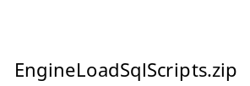

Acronym List
- GALC – Global Auto Line Control
- HMIN – Honda Manufacturing of Indiana
- HAM – Honda of America, Mfg.
- HMA – Honda Manufacturing of Alabama
- VIN – Vehicle Identification Number
- PL – Project Lead
- WE – Weld department
- ST – Stamping department
- AF – Auto Frame department
- VQ – Vehicle Quality department

Environment
This section describes the environment that the test was executed against.

Environment | WAS Version | App Server | DB Server | OPC Server | Device

Test Execution

Test Case 1 – Normal Flow

Pre-Conditions
- The Engine Load process point must be setup in configuration services
  - 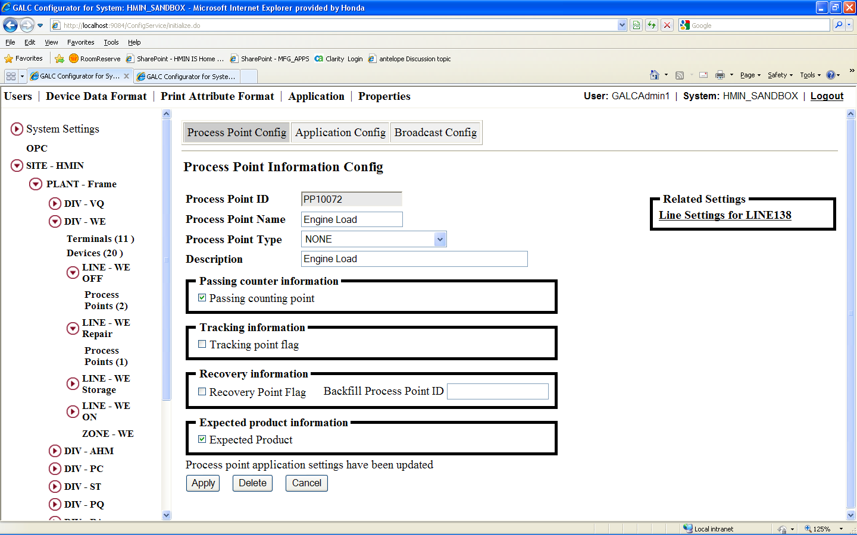
  - 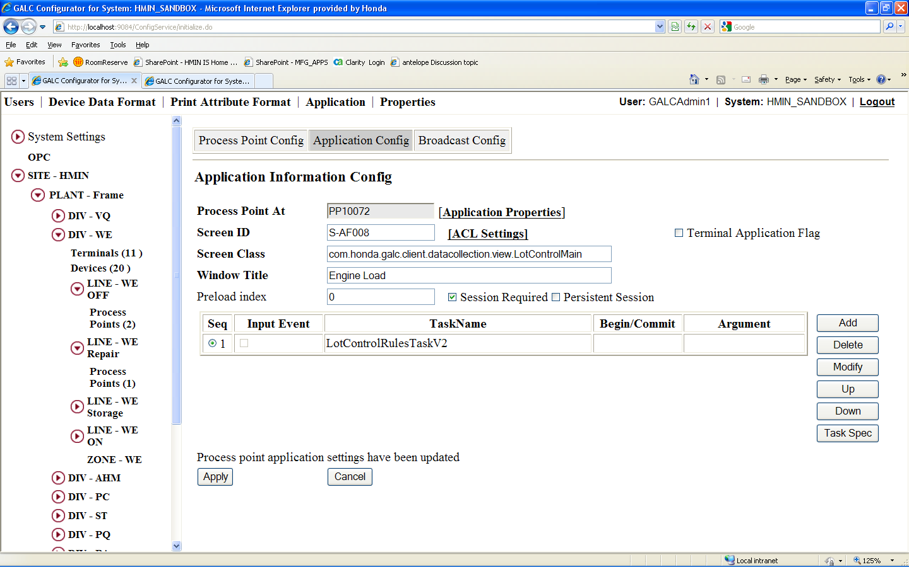
  - 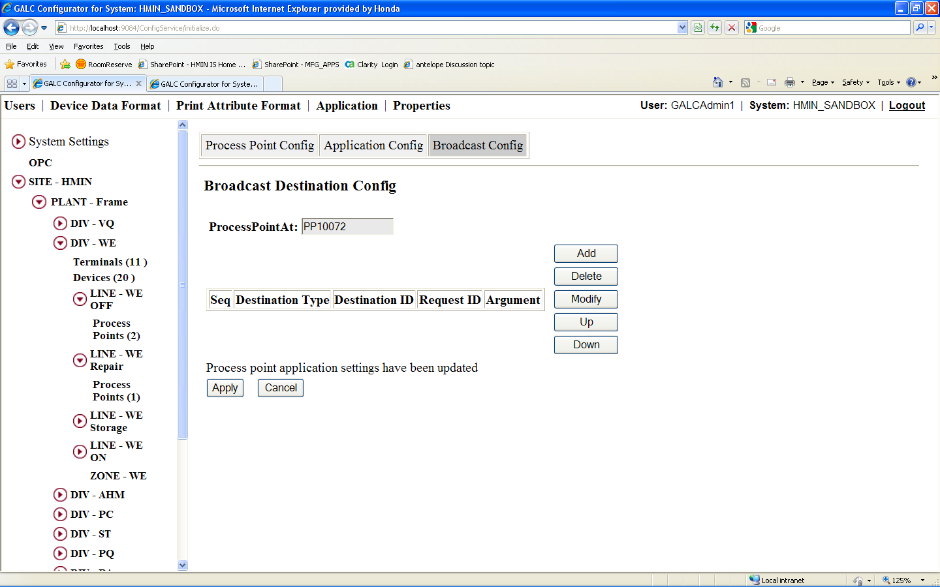

- Run the EngineLoadDataSetup.sql script to setup data to satisfy the following conditions
  - Deletes any hold records on the test VINs
  - Updates the next expected VIN for the process point
  - Updates the in process product records for the frames to have the right status and next expected product ids
  - Updates the frame table to have the right tracking status and remove any installed engine records
  - Updates the in process product records for the engines to have the data expected from AEP for the test engines
  - Updates the engine table to have the data expected from AEP for the test engines
  - Deletes any existing production result records for the VIN at the process point

Purpose
The purpose of this station is to associate an engine serial number with a VIN and updates the tracking of both the frame and engine. When the previous Prod Lot KD value is different form the current Prod Lot KD value yellow buildsheets should print, else white buildsheets should print.

Major Tables
- GAL131TBX ENGINE
- GAL135TBX EXPECTED PRODUCT
- GAL143TBX FRAME
- GAL147TBX HOLD RESULT
- GAL176TBX IN PROCESS PRODUCT
- GAL215TBX PRODUCTION RESULT

Test Steps
This section describes the steps to be taken in order to execute the test.

Step | Procedure | Expected Results | Actual Results | Pass/Fail
1 | Open the client | The Next Expected VIN is displayed in a green field.  The MTOC of the next VIN is displayed.  The expected engine type is displayed. | As expected | Pass
2 | Scan or manually enter an engine serial number matching the engine type expected. | The engine serial number is displayed on the screen. | As expected | Pass
3 | System checks that the VIN exists and is in the correct line status | No errors occur | As expected | Pass
4 | System checks that there is not an engine already assigned to the VIN | No errors occur | As expected | Pass
5 | System checks the status of the engine, that it is not already assigned to a VIN, and that it is the correct type | No errors occur | As expected | Pass
6 | System updates the next expected VIN for the process point | The expected product record in the database for the process point is updated to the next product id from the in process product table | As expected | Pass
7 | System updates the engine status and engine serial number of the frame | For the frame record in the database the engine status is changed to a 1 and the engine serial number is the serial number entered | As expected | Pass
8 | System updates the VIN, tracking status, last passing process point id, and mission status of the engine | For the engine record in the database the VIN is the processed, the tracking status is the engine load line ID, the last passing process point is engine load, and the mission status is 1 | As expected | Pass
9 | System checks that the frame came from an previous line | No errors occur | As expected | Pass
10 | System updates the tracking status of the frame | The tracking status of the frame record in the database is changed to the line ID of the engine load line | As expected | Pass
11 | System updates the in process product table | The next expected product of the in process product record for the current VIN is changed to null, and the line ID is changed to the engine load line. The most recent in process product for the engine load line with a null next product id has it’s next product id changed to the current VIN | As expected | Pass
12 | System updates the last passing process point id of the frame and in process product records | The frame and in process product records in the database for the current VIN have the engine load process point ID as their last passing process point ID | As expected | Pass
13 | System creates a product result record for the VIN and process point | The database contains a production result record for the current VIN and process point with the current time | As expected | Pass
14 | System increments the counter, counter by production lot, counter by product spec, and counter by model group count records for the current date, shift, and period | The counter, counter by production lot, counter by product spec, and counter by model group count records for the current date, shift, and period are incremented from their starting values. | As expected | Pass
15 | System removes the in process product record for the engine from the database | The database no longer has an in process product record for the engine | As expected | Pass
16 | System creates a product results record for the engine and process point | The database contains a product result record for the engine serial number and engine load process point | As expected | Pass
17 | System refreshes the screen | The screen is refreshed with the next expected VIN, MTOC, and expected engine type | As expected | Pass
18 | System broadcasts the engine build sheet print | The engine build sheet prints | As expected | Pass
19 | Repeat steps till you have an Prod Lot KD change, so both yellow and white sheets are executed. |  | As expected

Step 1 - 3
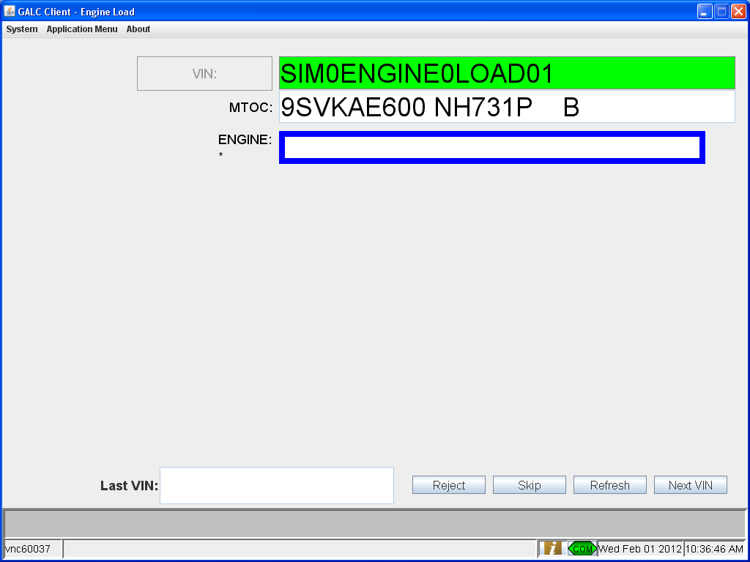

Step 6
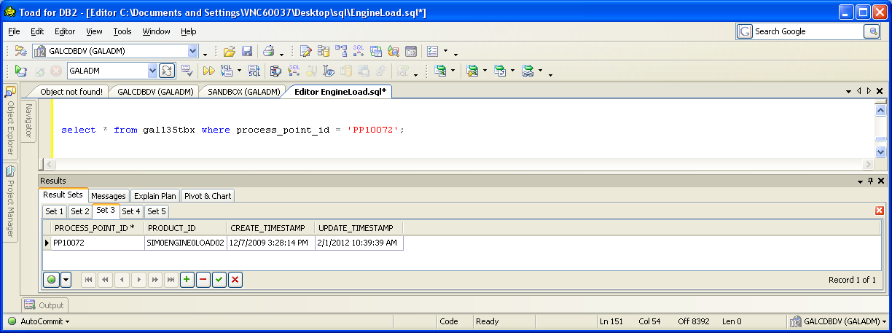

Step 7
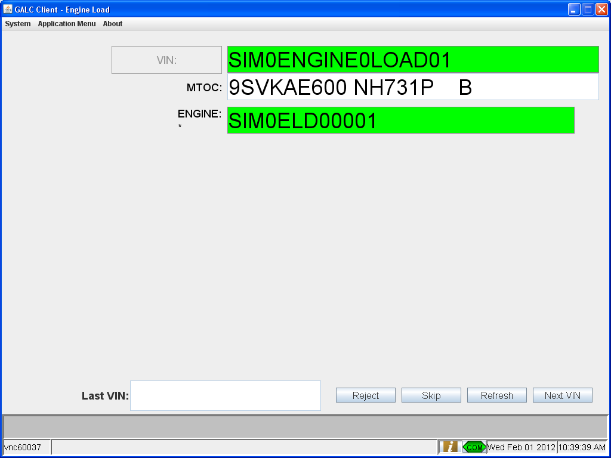

Step 8
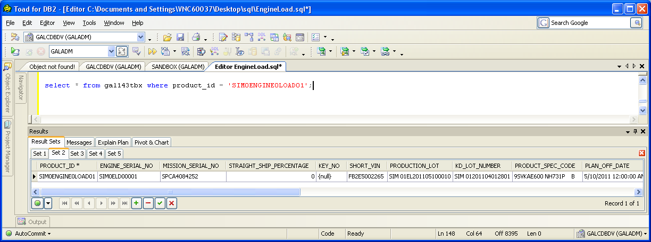

Step 10
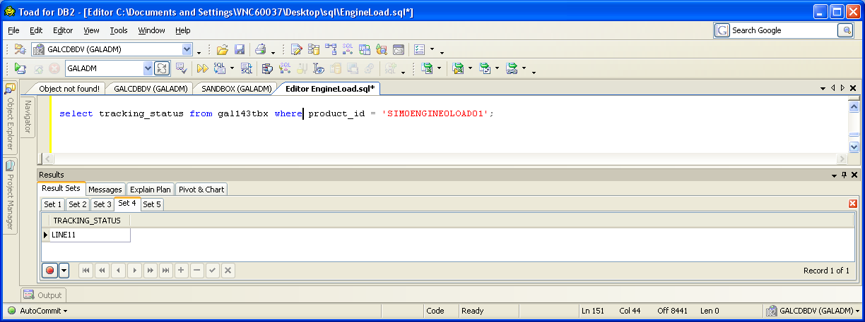

Step 11 & 12
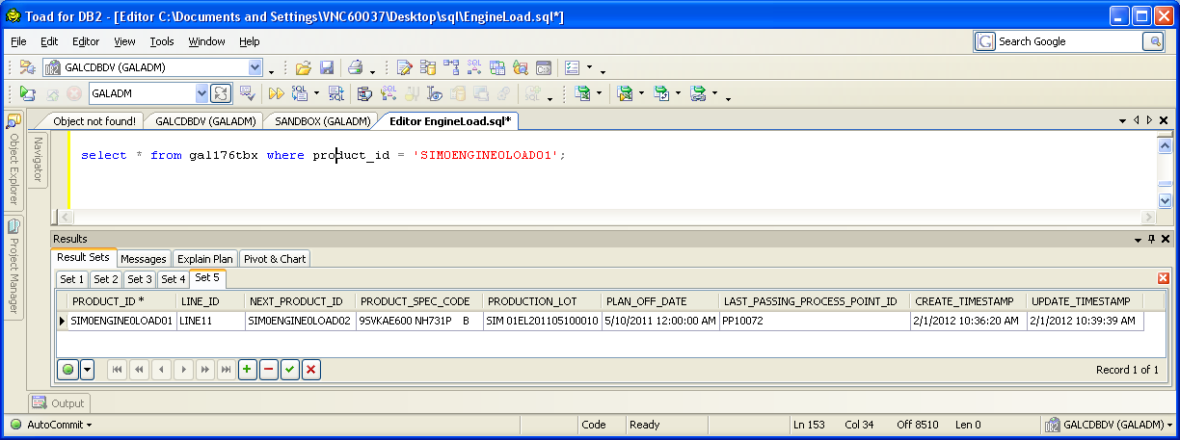

Step 13
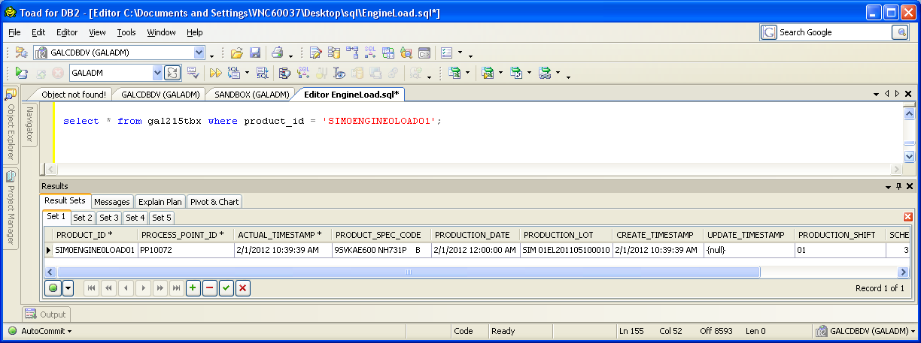

Step 15
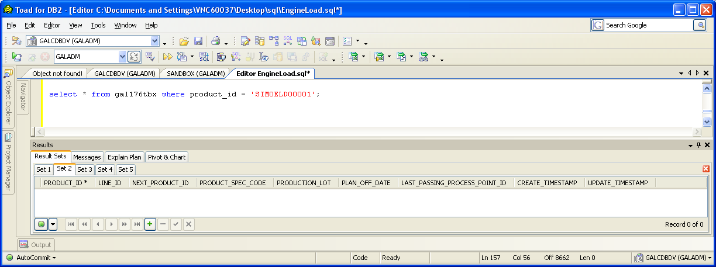

Step 16 for engine see Step 13 for vin
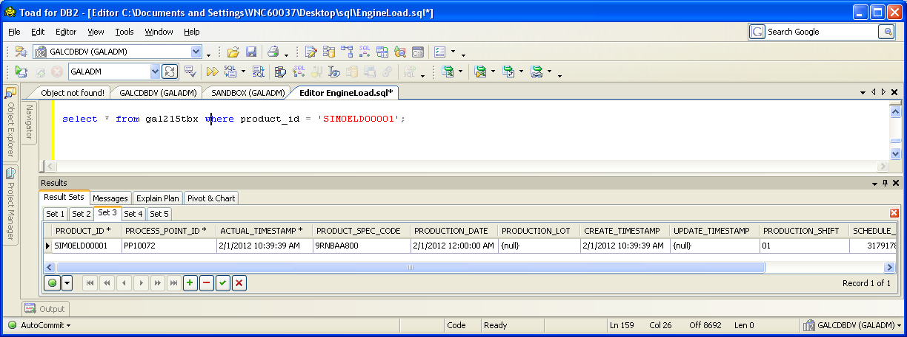

Step 17 Refresh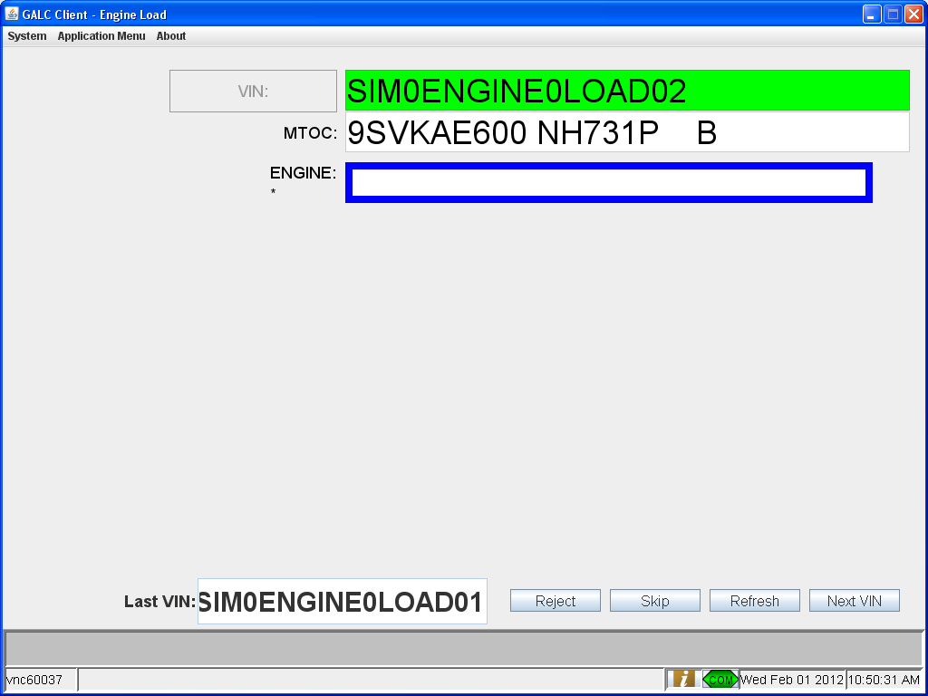

Post-Conditions
This section describes the steps to reset the test so that it can be executed multiple times. A post-condition is a condition or predicate that must always be true just after the execution of some section of code or after an operation in a formal specification. This may include such things as manually removing data or running a script to reset the test.
- None

Test Case 2 – Engine Not the Expected Type

Pre-Conditions
- The Engine Load process point must be setup in configuration services. See section 4.1.1
- Run the EngineLoadDataSetup.sql script to setup data to satisfy the following conditions
  - Deletes any hold records on the test VINs
  - Updates the next expected VIN for the process point
  - Updates the in process product records for the frames to have the right status and next expected product ids
  - Updates the frame table to have the right tracking status and remove any installed engine records
  - Updates the in process product records for the engines to have the data expected from AEP for the test engines
  - Updates the engine table to have the data expected from AEP for the test engines
  - Deletes any existing production result records for the VIN at the process point

Purpose
The purpose of this station is to associate an engine serial number with a VIN and updates the tracking of both the frame and engine

Major Tables
- GAL131TBX ENGINE
- GAL135TBX EXPECTED PRODUCT
- GAL143TBX FRAME
- GAL147TBX HOLD RESULT
- GAL176TBX IN PROCESS PRODUCT
- GAL215TBX PRODUCTION RESULT

Test Steps
This section describes the steps to be taken in order to execute the test.

Step | Procedure | Expected Results | Actual Results | Pass/Fail
1 | Open the client | The Next Expected VIN is displayed in a green field.  The MTOC of the next VIN is displayed.  The expected engine type is displayed. | As expected | Pass
2 | Scan or manually enter an engine serial number that does not match the engine type expected. | The engine serial number is displayed on the screen. | As expected | Pass
3 | System checks that the VIN exists and is in the correct line status | No errors occur | As expected | Pass
4 | System checks that there is not an engine already assigned to the VIN | No errors occur | As expected | Pass
5 | System checks the status of the engine, that it is not already assigned to a VIN, and that it is the correct type | System returns an error that the engine type does not match | As expected | Pass
6A | Scan or manually enter an engine serial number matching the engine type expected. | System continues processing normally with the new engine S/N | As expected | Pass
6B | Scan the Wrong E/M OK barcode | System continues processing normally with the unexpected engine type | As expected | Pass

Step 1 – 5
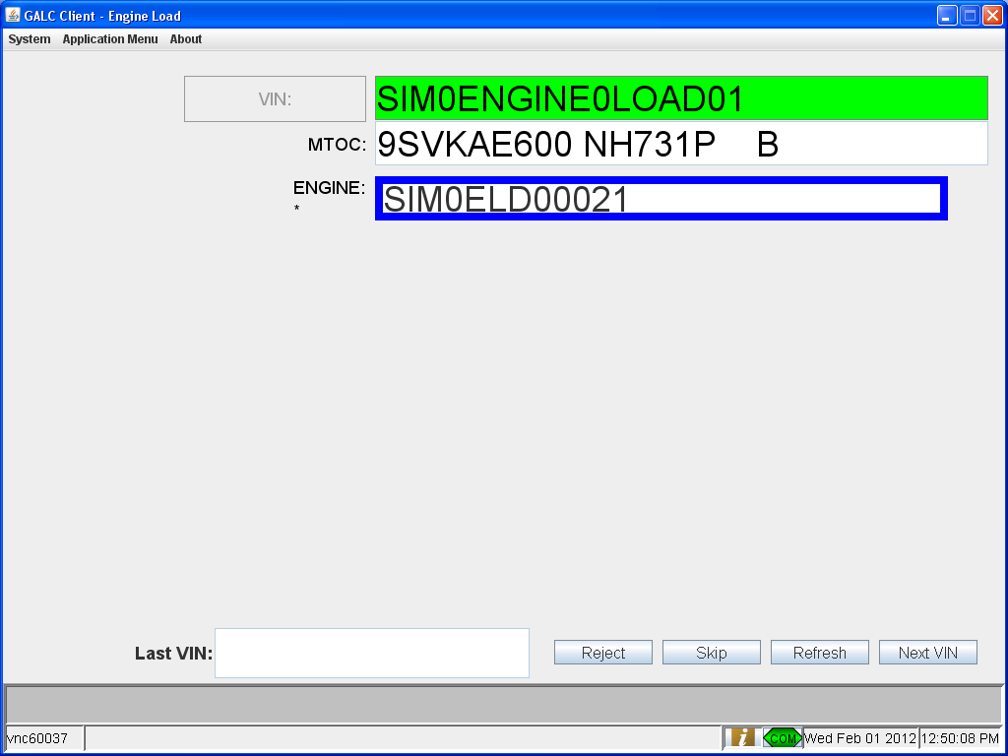

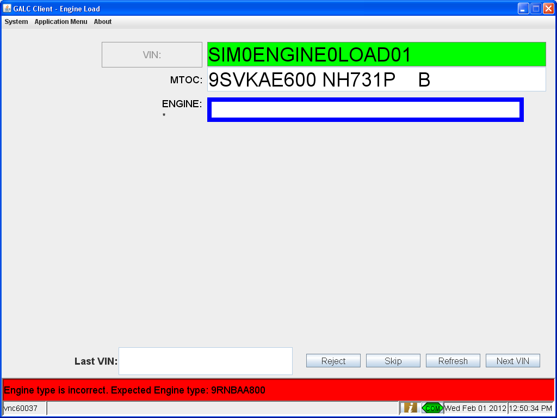

Step 6 & 7

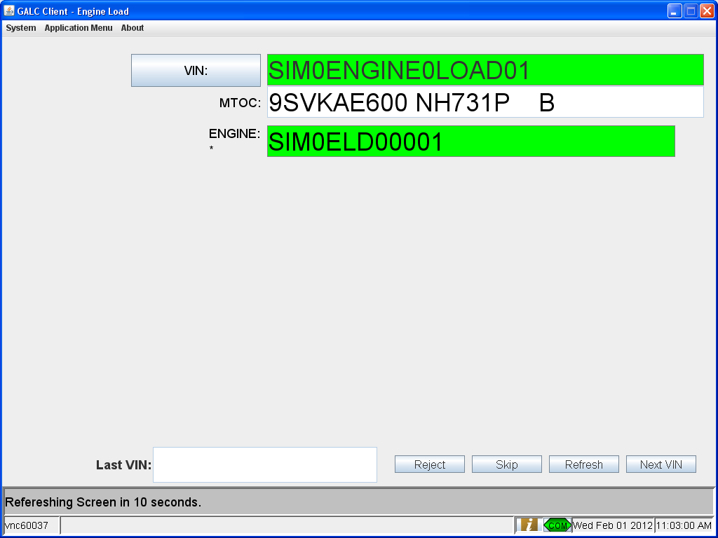

Post-Conditions
This section describes the steps to reset the test so that it can be executed multiple times. A post-condition is a condition or predicate that must always be true just after the execution of some section of code or after an operation in a formal specification. This may include such things as manually removing data or running a script to reset the test.
- None

Test Case 3 – No Expected VIN

Pre-Conditions
- The Engine Load process point must be setup in configuration services. See section 4.1.1
- Run the EngineLoadDataSetup_NoNextExpected.sql script to setup data to satisfy the following conditions
  - Deletes any hold records on the test VINs
  - Deletes the next expected VIN for the process point
  - Updates the in process product records for the frames to have the right status and next expected product ids
  - Updates the frame table to have the right tracking status and remove any installed engine records
  - Updates the in process product records for the engines to have the data expected from AEP for the test engines
  - Updates the engine table to have the data expected from AEP for the test engines
  - Deletes any existing production result records for the VIN at the process point

Purpose
The purpose of this station is to associate an engine serial number with a VIN and updates the tracking of both the frame and engine

Major Tables
- GAL131TBX ENGINE
- GAL135TBX EXPECTED PRODUCT
- GAL143TBX FRAME
- GAL147TBX HOLD RESULT
- GAL176TBX IN PROCESS PRODUCT
- GAL215TBX PRODUCTION RESULT

Test Steps
This section describes the steps to be taken in order to execute the test.

Step | Procedure | Expected Results | Actual Results | Pass/Fail
1 | Open the client | The next expected vin box is not populated. No errors displayed | As expected | Pass
2 | Scan the VIN | VIN should be validated and the the VIN box should turn green | As expected | Pass

Step 1
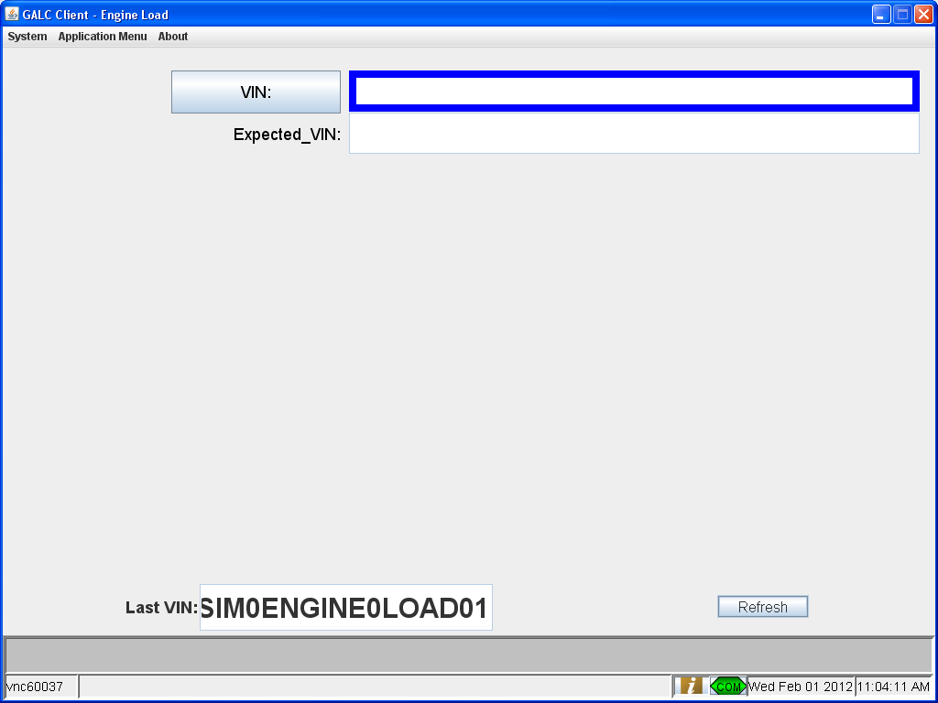

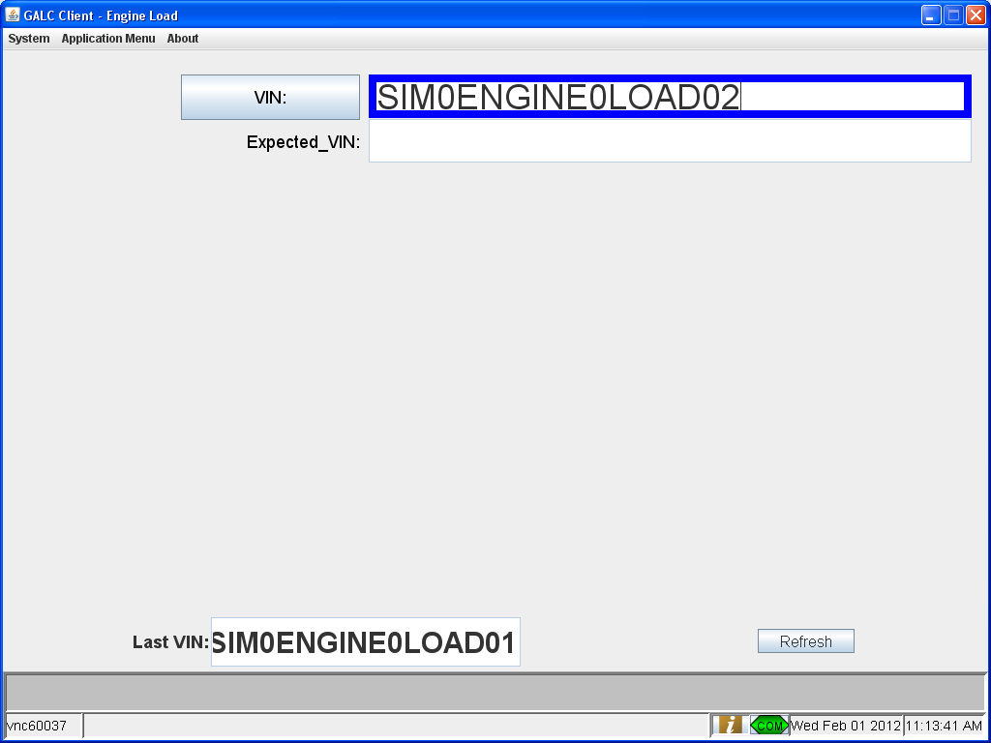

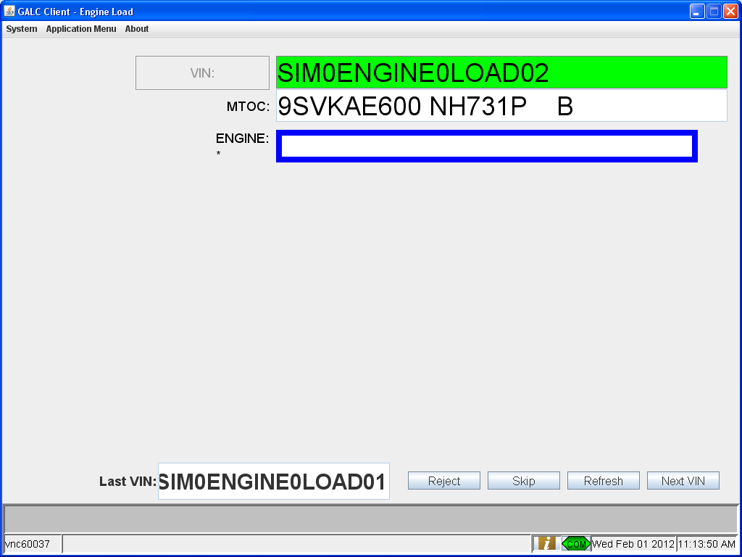

Post-Conditions
This section describes the steps to reset the test so that it can be executed multiple times. A post-condition is a condition or predicate that must always be true just after the execution of some section of code or after an operation in a formal specification. This may include such things as manually removing data or running a script to reset the test.
- None

Test Case 4 – No Engine Record

Pre-Conditions
- The Engine Load process point must be setup in configuration services. See section 4.1.1
- Run the EngineLoadDataSetup.sql script to setup data to satisfy the following conditions
  - Deletes any hold records on the test VINs
  - Updates the next expected VIN for the process point
  - Updates the in process product records for the frames to have the right status and next expected product ids
  - Updates the frame table to have the right tracking status and remove any installed engine records
  - Updates the in process product records for the engines to have the data expected from AEP for the test engines
  - Deletes the engine record for the test engine serial number from the engine table
  - Deletes any existing production result records for the VIN at the process point

Purpose
The purpose of this station is to associate an engine serial number with a VIN and updates the tracking of both the frame and engine

Major Tables
- GAL131TBX ENGINE
- GAL135TBX EXPECTED PRODUCT
- GAL143TBX FRAME
- GAL147TBX HOLD RESULT
- GAL176TBX IN PROCESS PRODUCT
- GAL215TBX PRODUCTION RESULT

Test Steps
This section describes the steps to be taken in order to execute the test.

Step | Procedure | Expected Results | Actual Results | Pass/Fail
1 | Open the client | The Next Expected VIN is displayed in a green field.  The MTOC of the next VIN is displayed.  The expected engine type is displayed. | As expected | Pass
2 | Scan or manually enter an engine serial number matching the engine type expected. | The engine serial number is displayed on the screen. | As expected | Pass
3 | System checks that the VIN exists and is in the correct line status | No errors occur | As expected | Pass
4 | System checks that there is not an engine already assigned to the VIN | No errors occur | As expected | Pass
5 | System checks the status of the engine, that it is not already assigned to a VIN, and that it is the correct type | System displays an error message stating the engine does not exist | As expected | Pass

Step 1 – 5
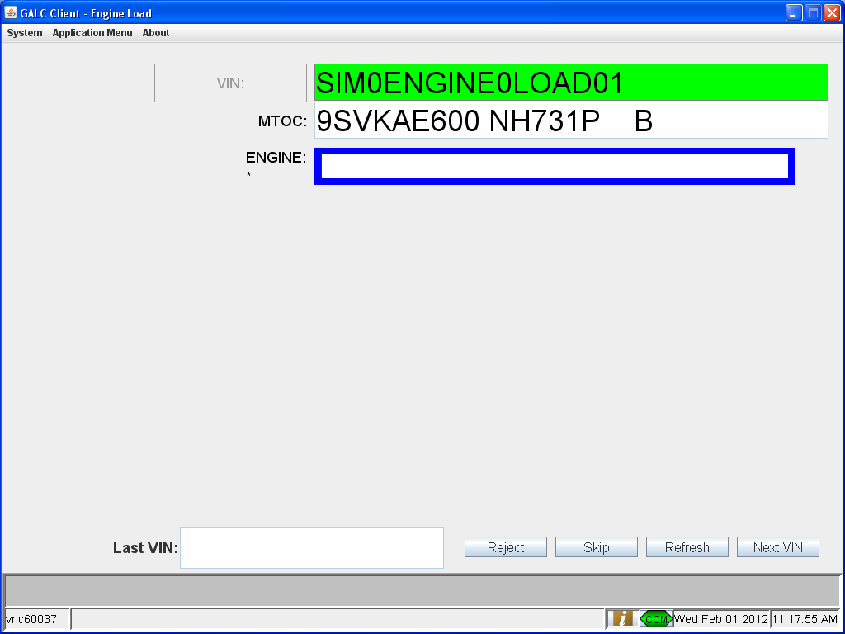

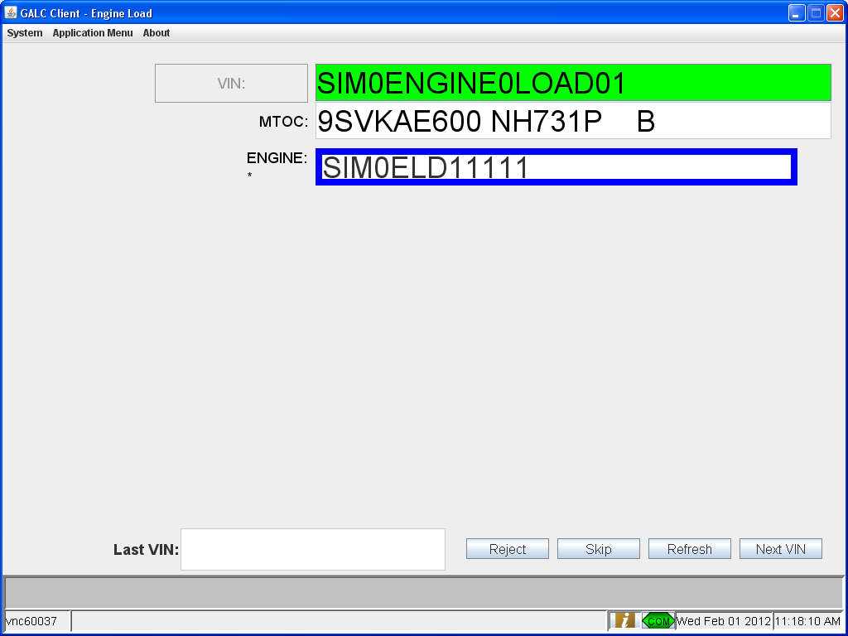

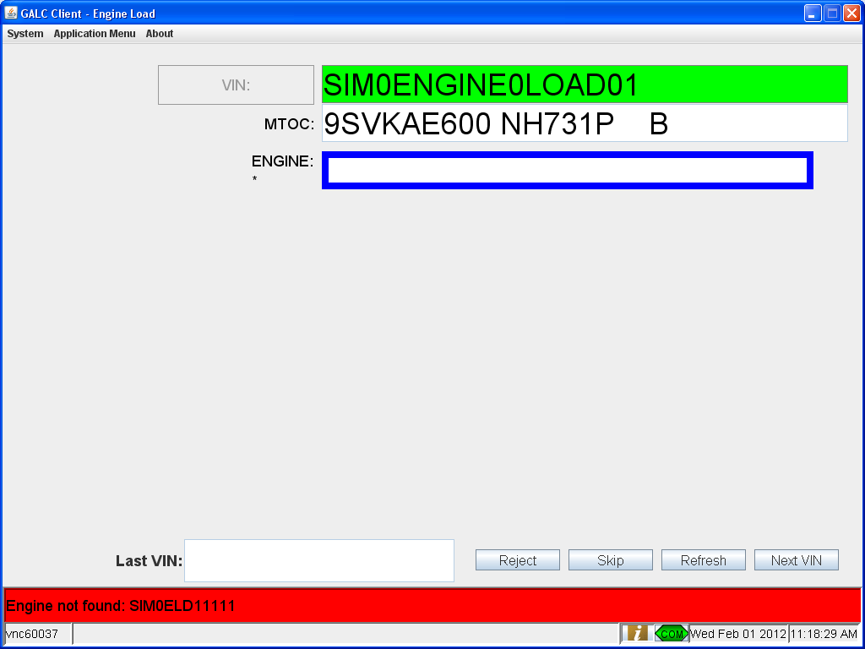

Post-Conditions
This section describes the steps to reset the test so that it can be executed multiple times. A post-condition is a condition or predicate that must always be true just after the execution of some section of code or after an operation in a formal specification. This may include such things as manually removing data or running a script to reset the test.
- None

Test Case 5 – VIN from Unexpected Line

Pre-Conditions
- The Engine Load process point must be setup in configuration services. See section 4.1.1
- Run the EngineLoadDataSetup_FrameWrongLine.sql script to setup data to satisfy the following conditions
  - Deletes any hold records on the test VINs
  - Updates the next expected VIN for the process point
  - Updates the in process product records for the frames to have the right status and next expected product ids
  - Updates the frame table to give the frame an unexpected status and remove any installed engine records
  - Updates the in process product records for the engines to have the data expected from AEP for the test engines
  - Updates the engine table to have the data expected from AEP for the test engines
  - Deletes any existing production result records for the VIN at the process point

Purpose
The purpose of this station is to associate an engine serial number with a VIN and updates the tracking of both the frame and engine

Major Tables
- GAL131TBX ENGINE
- GAL135TBX EXPECTED PRODUCT
- GAL143TBX FRAME
- GAL147TBX HOLD RESULT
- GAL176TBX IN PROCESS PRODUCT
- GAL215TBX PRODUCTION RESULT

Test Steps
This section describes the steps to be taken in order to execute the test.

Step | Procedure | Expected Results | Actual Results | Pass/Fail
1 | Open the client | The Next Expected VIN is displayed in a green field.  The MTOC of the next VIN is displayed.  The expected engine type is displayed. | As expected | Pass
2 | Scan or manually enter an engine serial number matching the engine type expected. | The engine serial number is displayed on the screen. | As expected | Pass
3 | System checks that the VIN exists and is in the correct line status | System displays an error that the VIN is not in AF ON | As expected | Pass

Step 1 – 3
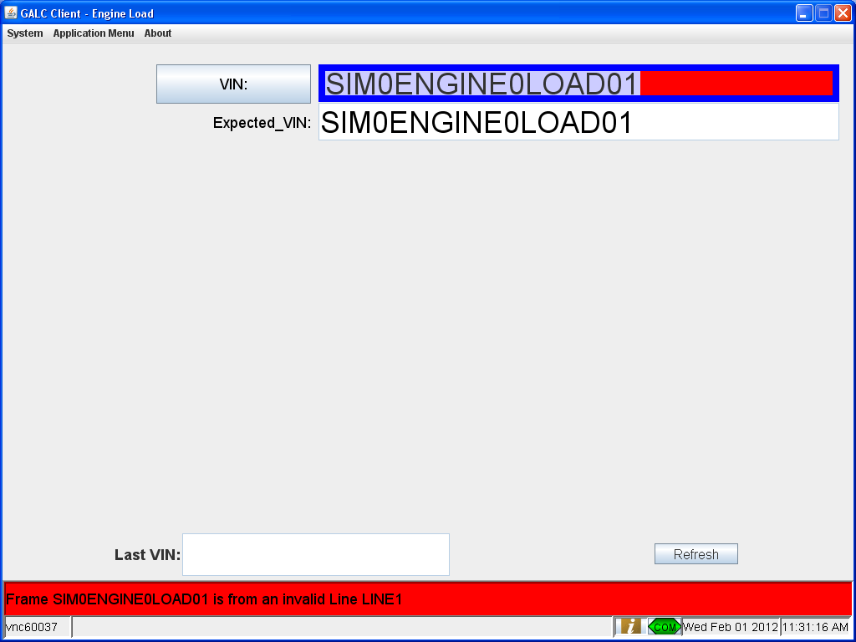

Post-Conditions
This section describes the steps to reset the test so that it can be executed multiple times. A post-condition is a condition or predicate that must always be true just after the execution of some section of code or after an operation in a formal specification. This may include such things as manually removing data or running a script to reset the test.
- None

Test Case 6 – No Frame Record for Expected VIN

Pre-Conditions
- The Engine Load process point must be setup in configuration services. See section 4.1.1
- Run the EngineLoadDataSetup_NoFrame.sql script to setup data to satisfy the following conditions
  - Deletes any hold records on the test VINs
  - Updates the next expected VIN for the process point
  - Updates the in process product records for the frames to have the right status and next expected product ids
  - Deletes the frame record for the expected VIN
  - Updates the in process product records for the engines to have the data expected from AEP for the test engines
  - Updates the engine table to have the data expected from AEP for the test engines
  - Deletes any existing production result records for the VIN at the process point

Purpose
The purpose of this station is to associate an engine serial number with a VIN and updates the tracking of both the frame and engine

Major Tables
- GAL131TBX ENGINE
- GAL135TBX EXPECTED PRODUCT
- GAL143TBX FRAME
- GAL147TBX HOLD RESULT
- GAL176TBX IN PROCESS PRODUCT
- GAL215TBX PRODUCTION RESULT

Test Steps
This section describes the steps to be taken in order to execute the test.

Step | Procedure | Expected Results | Actual Results | Pass/Fail
1 | Open the client | System displays an error that the VIN does not exist | As expected | Pass

Step 1
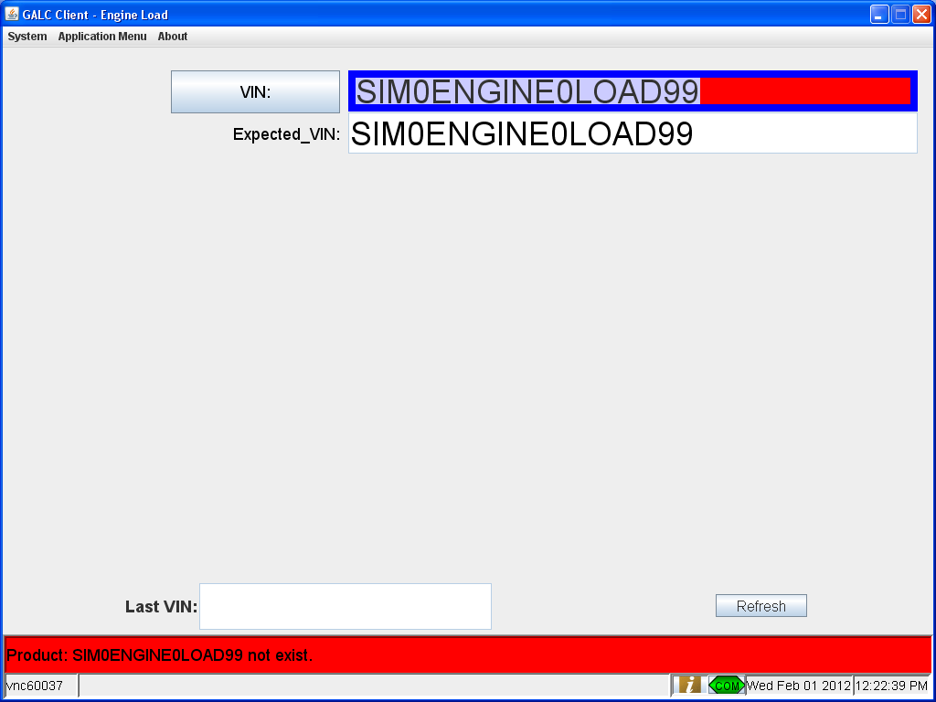

Post-Conditions
This section describes the steps to reset the test so that it can be executed multiple times. A post-condition is a condition or predicate that must always be true just after the execution of some section of code or after an operation in a formal specification. This may include such things as manually removing data or running a script to reset the test.
- None

Test Case 7 – Engine Already Processed

Pre-Conditions
- The Engine Load process point must be setup in configuration services. See section 4.1.1
- Run the EngineLoadDataSetup.sql script to setup data to satisfy the following conditions
  - Deletes any hold records on the test VINs
  - Updates the next expected VIN for the process point
  - Updates the in process product records for the frames to have the right status and next expected product ids
  - Updates the frame table to have the right tracking status
  - Updates the in process product records to remove the test engine
  - Updates the engine table to show the engine has already been associated with another frame
  - Deletes any existing production result records for the VIN at the process point

Purpose
The purpose of this station is to associate an engine serial number with a VIN and updates the tracking of both the frame and engine .If an already processed engine is used again, an error message stating that the Engine is already assigned to a different VIN.
Major Tables
- GAL131TBX ENGINE
- GAL135TBX EXPECTED PRODUCT
- GAL143TBX FRAME
- GAL147TBX HOLD RESULT
- GAL176TBX IN PROCESS PRODUCT
- GAL215TBX PRODUCTION RESULT

Test Steps
This section describes the steps to be taken in order to execute the test.

Step | Procedure | Expected Results | Actual Results | Pass/Fail
1 | Open the client | The Next Expected VIN is displayed in a green field.  The MTOC of the next VIN is displayed.  The expected engine type is displayed. | As expected | Pass
2 | Scan or manually enter an engine serial number matching the engine type expected but that has already been associated with another frame. | The engine serial number is displayed on the screen. | As expected | Pass
3 | System checks that the VIN exists and is in the correct line status | No errors occur | As expected | Pass
4 | System checks that there is not an engine already assigned to the VIN | No errors occur | As expected | Pass
5 | System checks the status of the engine, that it is not already assigned to a VIN, and that it is the correct type | System displays an error that the Engine is already assigned to a different VIN. | As expected | Pass
6 | Scan or manually enter an engine serial number matching the engine type expected. | The engine serial number is displayed on the screen. | As expected | Pass
7 | System checks that the VIN exists and is in the correct line status | No errors occur | As expected | Pass
8 | System checks that there is not an engine already assigned to the VIN | No errors occur | As expected | Pass
9 | System checks the status of the engine, that it is not already assigned to a VIN, and that it is the correct type | No errors occur. Processing continues normally | As expected | Pass

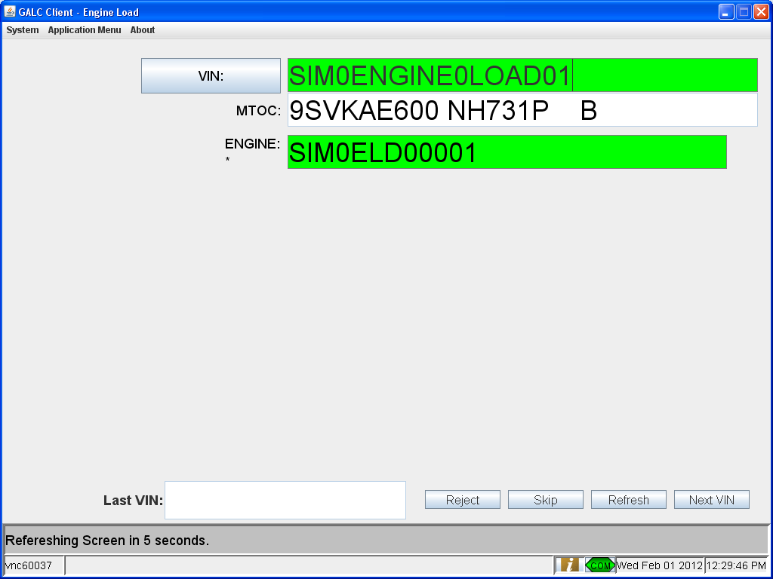

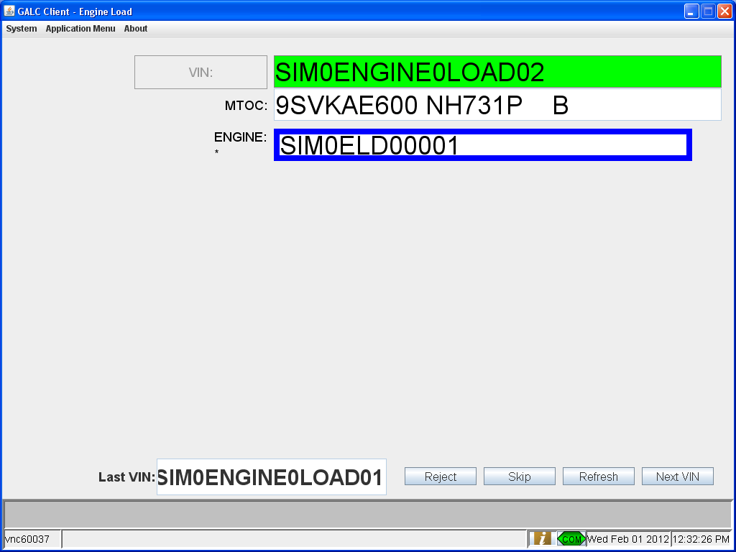

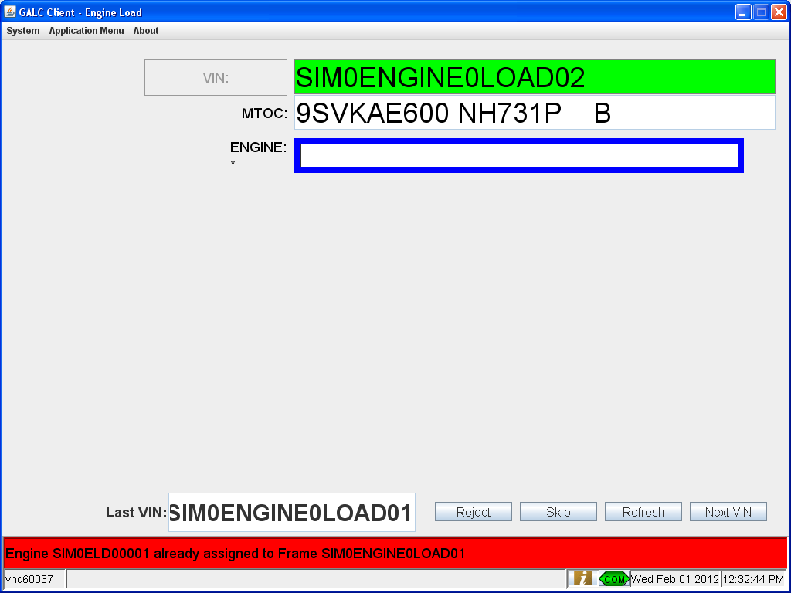

Post-Conditions
This section describes the steps to reset the test so that it can be executed multiple times. A post-condition is a condition or predicate that must always be true just after the execution of some section of code or after an operation in a formal specification. This may include such things as manually removing data or running a script to reset the test.
- None

Test Case 8 – Frame Already has an Engine

Pre-Conditions
- The Engine Load process point must be setup in configuration services. See section 4.1.1
- Run the EngineLoadDataSetup_AlreadyAssignedFrame.sql script to setup data to satisfy the following conditions
  - Deletes any hold records on the test VINs
  - Updates the next expected VIN for the process point
  - Updates the in process product records for the frames to have the right status and next expected product ids
  - Updates the frame table to give the test VIN the right tracking status and associate it with an engine
  - Updates the in process product records for the engines to have the data expected from AEP for the test engines
  - Updates the engine table to have the test engine already associated with a VIN
  - Deletes any existing production result records for the VIN at the process point

Purpose
The purpose of this station is to associate an engine serial number with a VIN and updates the tracking of both the frame and engine

Major Tables
- GAL131TBX ENGINE
- GAL135TBX EXPECTED PRODUCT
- GAL143TBX FRAME
- GAL147TBX HOLD RESULT
- GAL176TBX IN PROCESS PRODUCT
- GAL215TBX PRODUCTION RESULT

Test Steps
This section describes the steps to be taken in order to execute the test.

Step | Procedure | Expected Results | Actual Results | Pass/Fail
1 | Open the client | The Next Expected VIN is displayed in a green field.  The MTOC of the next VIN is displayed.  The expected engine type is displayed. | As expected | Pass
2 | Scan or manually enter an engine serial number matching the engine type expected | The engine serial number is displayed on the screen. | As expected | Pass
3 | System checks that the VIN exists and is in the correct line status | No errors occur | As expected | Pass
4 | System checks that there is not an engine already assigned to the VIN | System displays an error that the VIN already has a mission/engine assigned to it. | As expected | Pass

Step 1 - 4
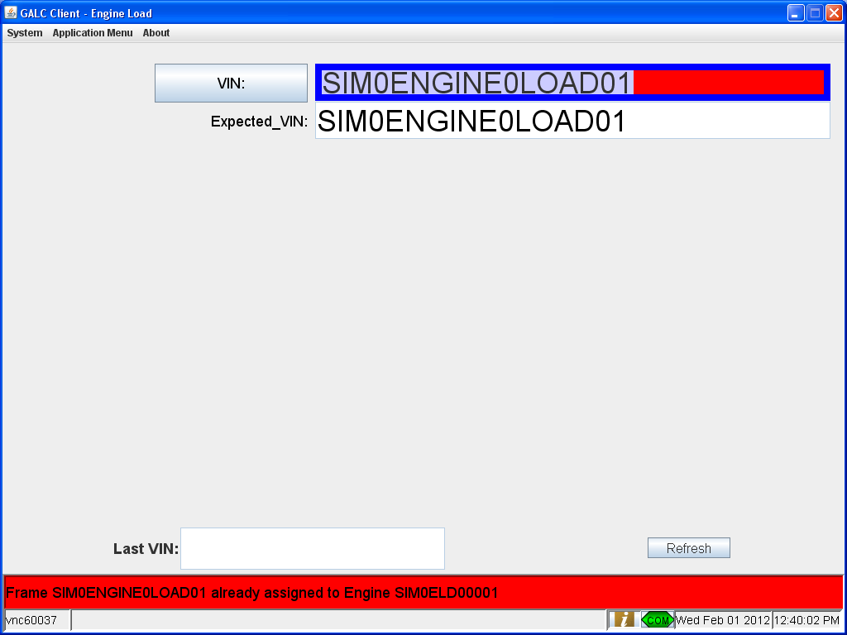

Post-Conditions
This section describes the steps to reset the test so that it can be executed multiple times. A post-condition is a condition or predicate that must always be true just after the execution of some section of code or after an operation in a formal specification. This may include such things as manually removing data or running a script to reset the test.
- None

